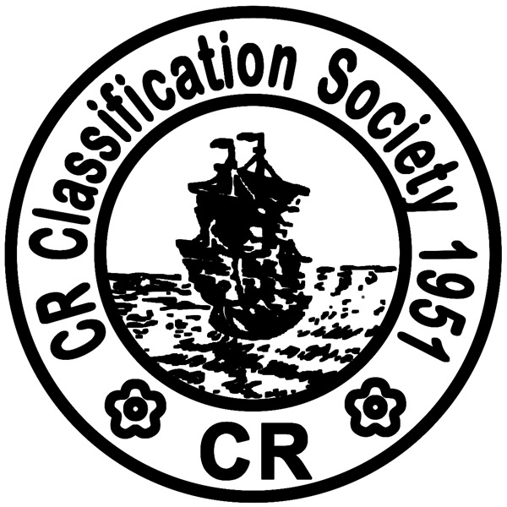

Tel : +886-2-2506-2711 Fax No.: +886-2-2507-4722
Website: www.crclass.org E-Mail: qcd@crclass.org

海事勞工公約(MLC)驗證申請書
APPLICATION FOR THE INSPECTION OF MARITIME LABOUR CONVENTION 2006

船東名稱NAME OF SHIP’S OWNER(中英文): |  |  | 識別碼ID NUMBER:
地址ADDRESS:
營運者名稱NAME OF SHIP’S OPERATOR(中英文): |  |  |  | 識別碼ID NUMBER:
地址ADDRESS:

申請者APPLICANT:
船東OWNER 營運者OPERATOR
連絡人姓名CONTACT PERSON: | 電話/手機 TEL/MOBILE: | 傳真FAX: |  |  | 電子信箱E-MAIL:

申請符合聲明第二部份審核APPLICATION FOR THE REVIEW OF DMLC-PART II:
(請附1.船舶國籍證書影本 2.簽署後之DMLC PART II及相關程序書等 3.最新一號的連續概要紀錄(CSR) Please provide 1. Copy of Certificate of Vessel’s Nationality 2. Endorsed DMLC Part II and relevant procedures 3.The Latest Continuous Synopsis Record(CSR))
船名SHIP NAME(中英文):

申請證書(MLC)項目:APPLICATION ITEM FOR MLC:
船名SHIP NAME :____________________________________________________ (中英文)
CR 登記號碼CR REGISTER NO.:__________________ IMO NO.:________________
臨時MLC 發證INTERIM MLC ISSUANCE 換證檢查RENEWAL INSPECTION
初次檢查INITIAL INSPECTION 額外檢查ADDITIONAL INSPECTION
中期檢查INTERMEDIATE INSPECTION
計劃何時何處接受檢查? When & where will Inspection be required? 地點Place_ ________________
日期Date_______ _
代理行連絡資訊 Agency information: _____________________________________________________

_________ _____________(__________)
日期Date 申請人簽名Signature 職稱Position

Form No.: XM97 / 12. 2014

