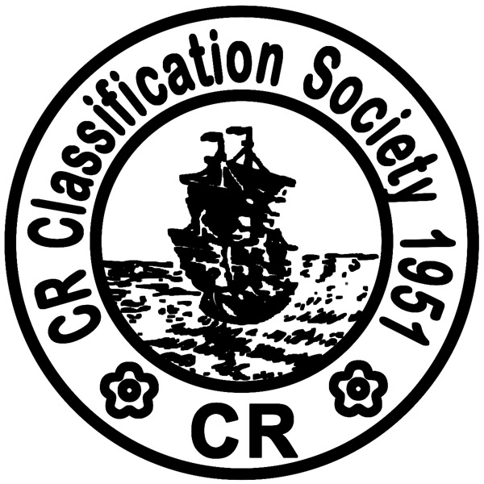

Tel : +886-2-2506-2711 Fax No.: +886-2-2507-4722
Website: www.crclass.org E-Mail: qcd@crclass.org

國際安全管理系統(ISM)驗證申請書
APPLICATION FOR THE VERIFICATION OF A SAFETY MANAGEMENT SYSTEM

公司名稱NAME OF COMPANY:
(中英文)

指派人員 DESIGNATE PERSON : |  | 公司識別碼COMPANY ID NUMBER: |  | 登記所有人識別碼  REGISTERED OWNER ID NUMBER:
地址ADDRESS:
連絡人姓名CONTACT PERSON: | 電話/手機 TEL/MOBILE: |  | 傳真 FAX: |  | 電子信箱 E-MAIL:

申請符合文件(DOC)項目APPLICATION ITEM(S) FOR DOC：
文件審查DOCUMENT REVIEW  公司訪談COMPANY VISIT  臨時驗證INTERIM VERIFICATION  初次驗證INITIAL VERIFICATION |  | 年度驗證ANNUAL VERIFICATION  換證驗證RENEWAL VERIFICATION  額外驗證ADDITIONAL VERIFICATION
計劃何時接受公司訪談? When will Company be visited? _____________________________________________
計劃何時接受稽核? When will Audits be required? __________________________________________________
船型 Ship Type  (*此次DOC稽核包含那幾種船型  *List types of ships of DOC audit) | 船名 Ship Name  (每種船型之船名Ship name of each type)

申請安全管理證書(SMC)項目APPLICATION ITEM FOR SMC：
船名SHIP NAME :____________________________________________________ (中英文)
CR 登記號碼CR REGISTER NO.:____________________
臨時驗證INTERIM VERIFICATION 換證驗證RENEWAL VERIFICATION
初次驗證INITIAL VERIFICATION 額外驗證ADDITIONAL VERIFICATION
中期驗證INTERMEDIATE VERIFICATION
計劃何時何處接受稽核? When & where will Audits be required? 地點Place_____________________
日期Date _____________________
代理行連絡資訊 Agency information: _________________________________________________
_________ _____________(__________)
日期Date 申請人簽名Signature 職稱Position

Form No.: XM42/ 03. 2020

